**Sean Poston**

**CY201 AxCrypt Lab**

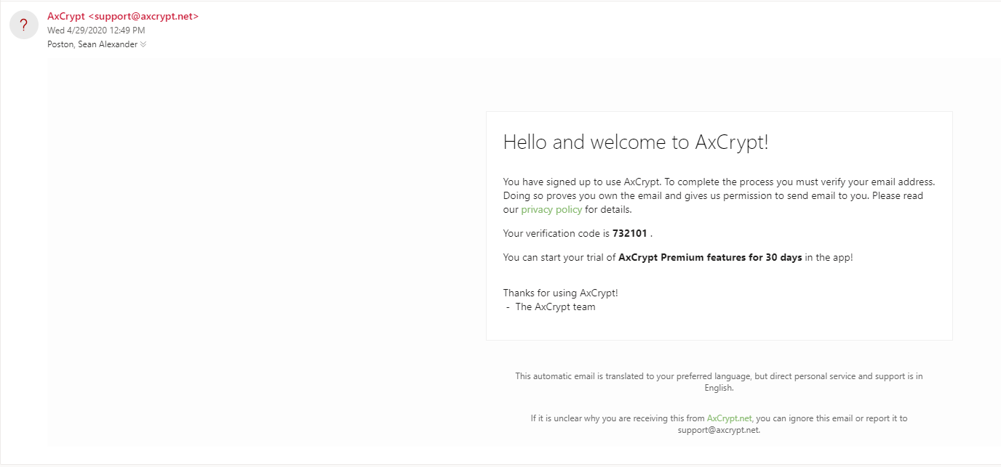

1. The encryption algorithm used is AES-256.

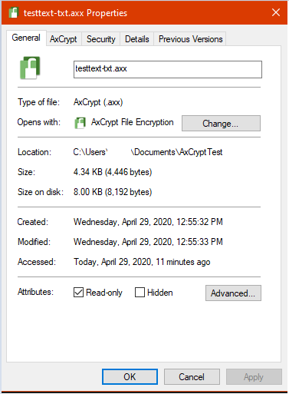

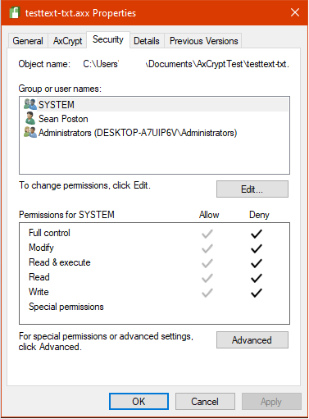

1. This question and question 5 seem like the same question, so I’m going to answer them both here. This lab is definitely useful in teaching me how to use something like AxCrypt. I had no idea such software existed before this because I’ve never needed it. I imagine I’d want to use something like this if I was sending sensitive, personal information like my SSN or credit card information over the internet. This sort of software would be immensely more valuable to people who are regularly sending and receiving valuable information.
2. See question 4.